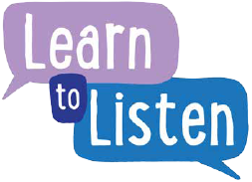
Have your say – Consent form
We’re planning to ask young people about …………………………………………………….... and we’d love your child to be involved.
Please complete this form and return it to the person named at the end:
Name of young person
Address

Telephone/email
Age and Date of Birth
Group/church/school which the participant represents
Any medical conditions or dietary requirements which the organisers need to be aware of

Name of parent/guardian
Address

Telephone/email
I/We give permission for (name) to take part. YES/NO
I/We give permission for photographs, videos or comments relating to this consultation to be used in publications and the parish website. YES/NO
I/We give permission for my child to be contacted via email in relation to the details and feedback from the consultation. YES/NO

Signed Parent/Guardian
Please return this form to:
Name
Telephone/Email
Address

