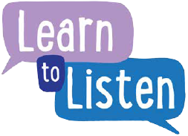
Have your say – Consultation details
We’re planning to hold a consultation about …………………………………..................................................... and we’d love your child to be involved.
Name of Consultation
Date

Venue

Start time

End time

Travel arrangements

Person in charge with contact details

We will provide light refreshments during the consultation.

If you would like your child to be part of this, please complete the Consent Form, sign it, and return it by DATE.

